Project 2 Design

Noah Niedzwiecki

ID: 903731690

Analysis:

As a member of the Branch Staff, the user has access to add clients and accounts, edit client information, manage account information, and save any made changes.

Adding a new client will ask for a series of information pertaining to the individuals private information including financial status. To add a new account the user first log in using their username and password. If correct credentials are input, the terminal will unlock with function specific to their status in the company, AKA: branch staff. Menu selection is done by inputting values corresponding to the action displayed on the screen. If an improper value is input the program will ignore it and will wait till a proper one is input. Because the user is a branch employee only certain options will be available to them. These options are all kept in the branch employee class. If the employee decides to edit accounts or create a new account, the name of the client or account will be asked for and searched in the database. If found it will display all the information available on that user. If not, it will ask if they would like to create that account.

All information pertaining to user accounts is stored in a text file local to the terminal. This includes admins and employees. However, all the client information is kept in a separate file. This is due to the drastic difference in qualities pertaining to the two.

Design:

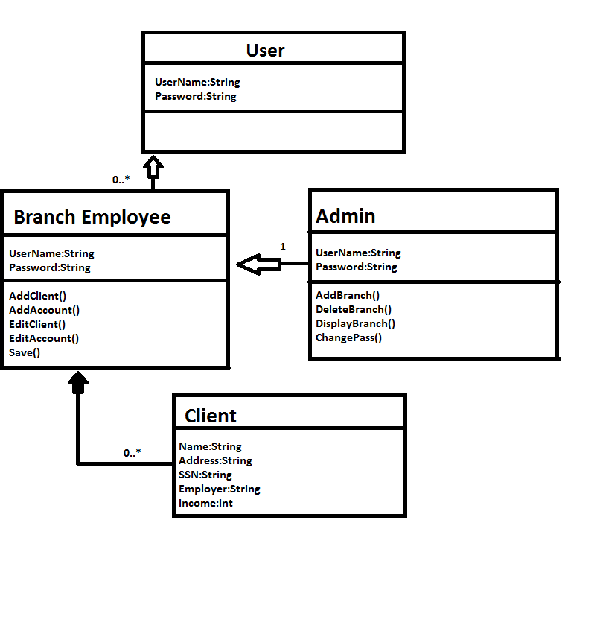

As an admin, the user has absolute control over all management and clients. This means that the options to add or delete employees is available exclusively to this class. Furthermore, all the functions accessible to the employees will also be functioning for admins. Complete control of the system.

All of the accounts will have several lines in a text file dedicated to them. The program will be able to determine where it is in the text file based off of determined symbols that will appear first in the line and nowhere else. Each property will have its own line. Based on the data type it will have to be parsed into the proper value by the program so it can properly be manipulated by the admin or employers.

There will be one admin to manage all the employees. However, there can be infinite employees and clients under them. The clients are critical to the employees because that is their entire job is to manage them. Each client will have the displayed variables and maybe more as the program progresses in design. Viewing account information will also be added in the future.

Testing:

1. In the case that an unqualified personnel or an extremely bad typer attempts to use the terminal. The terminal will not allow anyone without a valid username and password to use it. Maybe lockout function after a certain number of times will be added so that it requires an admin to login. Until decent inputs are inserted into the terminal the pc will display “Incorrect Username or Password”. Once correct codes are entered, based off the status of the account, the options available to them will be displayed on the screen.
2. If an employee or admin attempts to edit an account that doesn’t exist an option to create that account based off the named enter will be prompted back to the account manage screen. Whilst inputting values for a client, if the type does not make sense, say letters in a SSN or letters in an income amount, the prompt will ask for these to be input again until proper ones are submitted. Once all inputs are put into the file, the client will successfully be completed. If a balance is invalid it will default to 0. For example if the set balance of an account is “dffsd” then it will default to 0. If a user tries to deposit a silly amount it will deduct or add 0 to their value.
3. If a person tries to create an account for a client that hasn’t been saved in the system it will display that there are no current clients available. Only once they are added to the final will an account be made for them.
4. If a person tries editing an account after they just edited it and didn’t save, they will be prompted to save their past edits so that a new one can be processed.
5. If a person tries inputting a new empty password it will wait until a proper password is received. Therefore, prohibiting any possible login errors.
6. Unsaved edits are put in the accountsTemp.txt and clientsTemp.txt files. These continue to stay filled until the user exits the AccountManage page or saves them, effectively moving over the proper values to the final accounts.txt or clients.txt files.